General Purpose of the Program:

To remove “_Page_” from a file name from all files in a folder.

1. Select the **“Cannon Remake”** button in the control panel window.

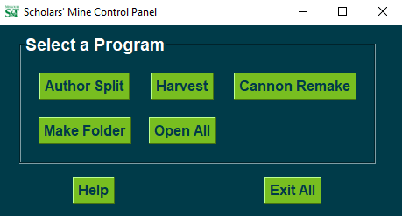

1. A window will appear and looks like this.

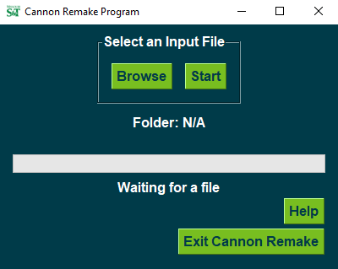

1. Click the **“Browse”** button to search for a folder.



1. Once the desired folder is located, click **“Select Folder”**.

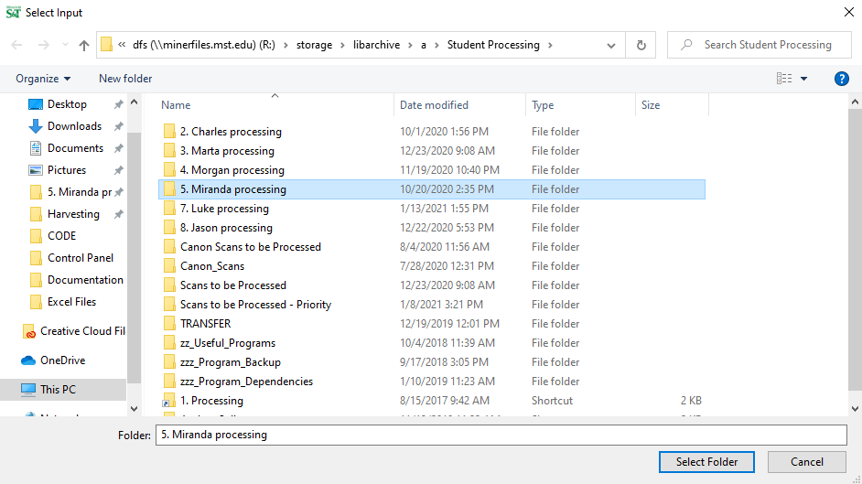

1. The folder name will appear in the window. Click on the **“Start”** button to begin.

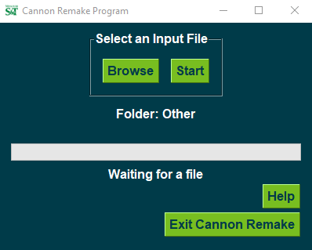

1. The progress bar will update when complete.

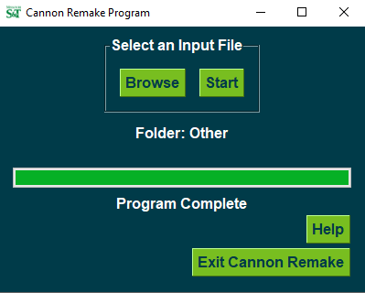

1. To repeat this program, select another folder with the **“Browse”** button and refer to step 3.
2. If you need to refer to this document, select the **“Help”** button at any time.

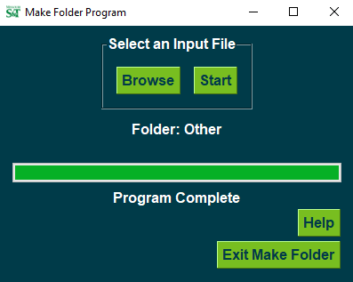

1. When you are done with the program you can either use the **“X”** at the top right corner of the window or press the **“Exit Cannon Remake”** button.

